

**T.C. AYDIN ADNAN MENDERES UNIVERSITY**

**FACULTY OF ENGINEERING**

**DEPARTMENT OF COMPUTER ENGINEERING**

**CSE402 Graduation Thesis 2, Spring 2020**

**Supervisor: Fatih SOYGAZİ**

**Cukatify**

**Music Social Media Web Platform**

**Final Report**

**(Bachelor of Science Thesis)**

**11.06.2020 Presentation Date**

**By:**

**Okan ÇİFTÇİ Student ID: 151805041**

# PLAGIARISM STATEMENT

This report was written by the group members and in our own words, except for quotations from published and unpublished sources which are clearly indicated and acknowledged as such. We are conscious that the incorporation of material from other works or a paraphrase of such material without acknowledgement will be treated as plagiarism according to the University Regulations. The source of any picture, graph, map or other illustration is also indicated, as is the source, published or unpublished, of any material not resulting from our own experimentation, observation or specimen collecting.

**Project Group Members:**

|  |  |  |  |
| --- | --- | --- | --- |
| Name, Lastname | Student Number | Signature | Date |
| Okan ÇİFTÇİ | 151805041 |  |  |

**Project Supervisors:**

|  |  |  |  |
| --- | --- | --- | --- |
| Name, Lastname | Department | Signature | Date |
| Fatih SOYGAZİ | Computer Science Engineering |  |  |

# ACKNOWLEDGEMENTS

I earn too much things in this project how to use NoSQL databases and data modeling in NoSQL how to do client side state management how to represent knowledge in web, how to use caching how to use SPARQL to access ontologies, how to use oAuth2 token for accessing external data, how to communicate services, how to use message queue, how to create recommender systems using collaborative filtering and hybrid content based systems, how to use architecture tests for system, how to collect data from web using on music industry, how to design multi role system, how to design producer-consumer system, how to preprocess data for machine learning algorithms.

# KEYWORDS

Spotify, Music, Ontology, DBpedia, Recommendation System, Redis, NOSQL, Spring Boot, Social Media, Description Logic, Data Analysis, Collaborative Filtering, Redux, Thunk, SPARQL, OWL, Jena, Genre, Knowledge, message queue, producer-consumer, content based filtering, kmeans, word2vec, autoencoders, machine learning, deep learning, unit test, integration test, architectural test, git, interaction, flask, rest, colabo

# ABSTRACT

Since the early 1950s people frequently listening music from different sources like record player, tape, mp3 player etc. This sources provide one way communication which is source to listener but with technology growth this change. Nowadays we listening music with different sources too but communication is more different between listener and source. Our goal is use to advanced learning techniques and knowledge representation to provide listeners use music sources more effectively like recommendation about new music, gain knowledge about musicians with those provided we hopefully create a web platform to people communicate each other and find music related stuff with these platform.

# ÖZET

Geçmişten günümüze müzik dinleyen insanlarla müzik arasında ki iletişime baktığımızda müzik 2010’ların başlarına kadar iletim yoluyla sadece dinleyen tarafından dinlenildi karşılıklı bir iletişim bulunmamaktaydı, teknolojinin gelişmesi ile birlikte müzik ile dinleyen arasında olan iletişim var olmaya ve artmaya devam etmektedir. Müzik dinleyen kişi çeşitli etkileşimler ile müziğin kaynağına etkide bulunabilmekte böylelikle aldığı etki farklı olmaktadır.Temel olarak amacımız kullanıcıları müzikler ile etkileşim haline geçirerek öğrenme teknikleri ile kullanıcılara çeşitli müzikler önermek, bilginin temsili ile kullanıcılara müzik grupları, sanatçılar hakkında bilgi vermek iletişimi arttırmak için kullanıcılar birbirine önermek aynı zamanda müzik dünyasında olan çeşitli etkinlikleri paylaşmak.

# TABLE OF CONTENTS

PLAGIARISM STATEMENT 2

ACKNOWLEDGEMENTS 4

KEYWORDS 5

ABSTRACT 6

ÖZET 7

TABLE OF CONTENTS 8

LIST OF ACRONYMS/ABBREVIATIONS 9

1. INTRODUCTION 1

1.1. Description of the Problem 1

1.2. Project Goal 1

1.3. Project Output 1

1.4. Project Activities and Schedule 1

2. DESIGN 2

2.1. High Level Design 2

2.2. Detailed Design 2

2.3. Realistic Restrictions and Conditions in the Design 2

3. IMPLEMENTATION, TESTS and TEST DISCUSSIONS 2

3.1. Implementation of the Product 2

3.2. Tests and Results of Tests 2

4. CONCLUSIONS 3

4.1. Summary 3

4.2. Cost Analysis 3

4.3. Benefits of the Project 3

4.4. Future Work 3

References 3

APPENDICES 4

User Stories, Sprint Planning, Product and Sprint Backlog 4

Diagrams - Screenshots 10

# LIST OF ACRONYMS/ABBREVIATIONS

AI Artificial Intelligence

KR Knowledge Representation

# 1. INTRODUCTION

# 1.1. Description of the Problem

In music society there are too many changes rapidly, listeners having trouble catching new events our aim in this project solve this problem for music lovers to feel comfortable around music society and also with recommendations we want to increase communication between users. There is a platforms which are Spotify and LastFM we use Spotify and LastFM pros but also add new features to increase diversity.

# 1.2. Project Goal

Project goal is going to create a web platform for access of end users via this platform users can access and use our platform also create detailed documentation about platform and collect new datasets for data science society. Our platform main goal is increase to communication between users and music environment.

# 1.3. Project Output

Our project output is a software product which runs on a server. Software product give output like recommendations, knowledge about music society, communication between users.

# 1.4. Project Activities and Schedule

* Determine requirements our project.
* Discuss about requirements.
* Arrange requirements.
* Analysis on requirements.
* Determine technologies which using in these project.
* Finding music related ontology.
* Creating ER diagram.
* Starting to develop backend.
* Starting to develop frontend.
* Starting to create post recommendation dataset.
* Starting to develop post recommendation service.
* Starting to create music recommendation dataset.
* Starting to develop music recommendation service.
* Starting to create producer-consumer system.
* Starting to communicate services with main system.
* Starting to implement authentication & authorization.

# 2. DESIGN

# 2.1. High Level Design

* In high level design, we think user interface and system architecture because of we use agile process development, our architecture is often changes also we think how to find and design recommendation systems.

# 2.2. Detailed Design

* In detailed design, we create entity relationship diagram, design entities and roles according to system also visualize whole system. We design recommendation services finally we think pattern what we can use in this project.

# 2.3. Realistic Restrictions and Conditions in the Design

Currently our knowledge representation is working good but not give us advanced recommendations now. We can build with more sophisticated way.

We can recommend songs more sophisticated way for example looking their lyrics too.

# 3. IMPLEMENTATION, TESTS and TEST DISCUSSIONS

# 3.1. Implementation of the Product

I use spring boot for backend also using react to manage frontend creating UIs with semantic ui also use DBpedia to access knowledge, use redis for caching and as message queue using NoSQL for storing data also use redux for state management to access DBpedia we use Apache Jena. I use Junit, Assert, ArchUnit for testing, I use tensorflow and scikit-learn and gensim to create machine learning models and extract features. I use flask for create recommendation apis, I use oAuth2 protocol to access Spotify data. I also use beautiful soup and regex for scraping data from web. I use pandas and numpy manipulate numerical and categorical data.

# 3.2. Tests and Results of Tests

Our project is pass written architectural and unit and integration tests but with new features we have to improve and add more unit tests also implement integration tests. Generally currently features are passed on implementation.

# 4. CONCLUSIONS

# 4.1. Summary

Until now we create our main project structure with both side also access DBpedia to represent our knowledge about music society. We create posts which give us information about news about music society. We use redis for caching and use as message queue We use Junit, assertJ, archUnit for project unit, integration, architecture testing. We create recommendation services for posts and song. We can login with Spotify and see currently listening song lyrics. We can see system users with song which they listening. We enabled multi role system. Finally we use git for version control.

# 4.2. Cost Analysis

I spent 5 months in development phase with me and project supervisor Fatih SOYGAZİ. We use our own hardware there isn’t any expenses except internet and electric bills.

# 4.3. Benefits of the Project

Our project main benefit is increase to interaction between users and music society with these project. Users can find a new music which will probably like. Users also can find new friends with these platform which will probably same taste in music also users can hear new magazines about music society.

# 4.4. Future Work

We will add user recommendations and chatting between users, look profiles and interact with users, post delete, update operations user crud operations, music recommendations with more sophisticated way. Implement pagination for viewing posts, use errors from exception handling more sophisticated way. We can use doctor for more easily organize our app. You can keep track project following link, <https://github.com/okanvk/Cukatify>

# References

<https://www.baeldung.com/>

<https://wiki.dbpedia.org/>

<https://redis.io/>

<https://spring.io/>

<https://tr.reactjs.org/>

<https://open.hpi.de/courses/semanticweb>

<https://www.palermo.edu/ingenieria/Pdf2010/CyT9/15.pdf>

<https://www.mongodb.com/>

<https://jena.apache.org/>

<https://www.archunit.org/>

<http://eecs.qmul.ac.uk/research/eecs-research-impact/semantic-web-for-music/>

<https://plantuml.com/>

<https://towardsdatascience.com/applied-deep-learning-part-3-autoencoders-1c083af4d798>

[mongodb.com](http://mongodb.com)

<https://trello.com/>

<https://tr.reactjs.org/>

<https://towardsdatascience.com/introduction-to-recommender-systems-6c66cf15ada>

<https://oauth.net/2/>

<https://developer.spotify.com/>

<https://junit.org/junit5/>

<https://medium.com/@muhammedbuyukkinaci/autoencoders-nedir-t%C3%BCrk%C3%A7e-4712c826f90e>

<https://app.diagrams.net/>

# APPENDICES

# User Stories, Sprint Planning, Product and Sprint Backlog

Theme: Authentication

Epic: As a User, I can login so that use application.

User Story:As a User,I can fill email and password fields so that I can login

User Story:As a User,I can use my Spotify account to login

Tasks:

1: Create page to user login

2: Create new table for Users

3: Create Spotify connection

4: After Login Redirect to Website Home Page

Epic: As a User, I can register so that login into application.

User Story:As a User,I can fill email and password fields so that I can register.

Tasks:

1: Create page to user register

2: After Login Redirect to Main Page

Epic: As a User, I can logout so that my account privacy can be more secure.

User Story:As a User,I click Log-out button in navbar so that I can log-out.

Tasks:

1: Create button for logout

Theme: Access Knowledge

Epic: As a User, I can access any artist/band knowledge and related artist/bands

User Story: As a User,I can fill search box and click ‘Search’ button on navbar so that access Artist/Band knowledge

User Story: As a User,I can find other related artist/band from current artist/band so that my access will be more sustainable

Tasks:

1:Create ‘Search Board’ button

2:Create SearchBox

3:Make Dbpedia connection

4:Design Artist page

5:Bring related artists

Theme: Access news about music

Epic: As a User, I can give ratings on posts so that I can express my emotions about post.

User Story:As a User,I can click ‘Give Rating’ button near the post and give rating so that post rating updated.

Tasks:

1:Create ‘Give Rating’ button.

2:Create Rating table for Ratings

3:Update Post Rating

Epic: As a Editor, I can do basic operations on posts so that site will be more interactive.

User Story:As a Editor, In Editor Page I can click ‘Create Post’ , Update Post’, Make Active/Passive’ buttons so that I can manipulate posts.

Tasks:

1:Create ‘Create Post’, ‘Update Post’, ‘Make Active/Passive’ button.

2:Create Post table for Posts.

3:Design pages about this operations.

Epic: As a User, I can take recommendations about posts so that I can explore new things

User Story:As a User,In a specific post, i can see other recommended posts to me.

Tasks:

1:Create Recommender System Service.

2:Design Post Detail Page.

Theme: Spotify

Epic: As a User, I can access Spotify data so that review my statistics.

User Story:As a User,I can see my favourite artists, most listen tracks so that realise my music taste.

Tasks:

1: Design Spotify Main Page

2: Access Spotify data

Epic: As a User, i can design my profile so that my profile looks better and more informative

User Story: As a User, i can edit social media links and edit bio so that my profile will be more attractive

Tasks:

1: Create new button for Add Social Media Links.

2: Create new button for Add Bio.

Theme: Admin

Epic: As a Admin, I can look app statistics so that found new features about this statistics

User Story:As a Admin,I can click ‘Admin Page’ from navbar so that admin page show statistics

Tasks:

1: Design Admin Page

2: Prepare Statistics

Epic: As a Admin, I can set new editors so that editors add new posts

User Story:As a Admin,I can click “New Editor” button so that we give editor role to user.

1: Create New Editor button

2: Create New Editor modal

Product Backlog

| ID | Story | Estimation | Priority |
| --- | --- | --- | --- |
| **1** | As a User, I can login so that use application. | 2 | 1 |
| **2** | As a User, I can register so that login into application | 2 | 2 |
| **3** | As a User, I can logout so that my account privacy can be more secure. | 2 | 3 |
| **4** | As a User,I can use my Spotify account to login | 3 | 4 |
| **5** | As a User,I can fill search box and click ‘Search’ button on navbar so that access Artist/Band knowledge | 3 | 5 |
| **6** | As a User,I can find other related artist/band from current artist/band | 4 | 6 |
| **7** | As a User,I can click ‘Give Rating’ button near the post and give rating so that post rating updated. | 3 | 7 |
| **8** | As a Editor, In Editor Page I can click ‘Create Post’ , ‘Update Post’, Make Active/Passive’ buttons so that I can manipulate posts. | 5 | 8 |
| **9** | As a User, I can take recommendations about posts so that I can explore new things | 3 | 9 |
| **10** | As a User,I can see my favourite artists, most listen tracks so that realise my music taste. | 3 | 10 |
| **11** | As a User, i can edit social media links and edit bio so that my profile will be more attractive | 3 | 11 |
| **12** | As a Admin,I can click ‘Admin Page’ from navbar so that admin page show statistics | 2 | 12 |
| **13** | As a Admin, I can set new editors so that editors add new posts | 2 | 13 |
| Total |  | **37** |  |

Sprint Planning

Sprint Planning for Sprint-1

We select this stories for this sprint.

What is the goal for this sprint?

In this spring we start project with some UI design and doing basic project requirements.

What product backlog items are ready and contribute toward the sprint goal?

We already selected our sprint backlog items from product backlog as you can see below.

Who is available for this sprint?

Everyone is available for this sprint, there is no holiday or vacations.

What is the team’s capacity?

1.

How confident does the team feel that they’ll be able to meet the sprint goal ?

They feel comfortable.

Sprint-1 Sprint Backlog

| ID | Story | Estimation | Priority |
| --- | --- | --- | --- |
| **1** | As a User, I can login so that use application. | 2 | 1 |
| **2** | As a User, I can register so that login into application | 2 | 2 |
| **3** | As a User, I can logout so that my account privacy can be more secure. | 2 | 3 |
| **4** | As a User,I can use my Spotify account to login | 3 | 4 |
| **5** | As a User,I can fill search box and click ‘Search’ button on navbar so that access Artist/Band knowledge | 3 | 5 |
| **6** | As a User,I can find other related artist/band from current artist/band | 4 | 6 |
| **7** | As a User,I can click ‘Give Rating’ button near the post and give rating so that post rating updated. | 3 | 7 |
| **8** | As a Editor, In Editor Page I can click ‘Create Post’ , ‘Update Post’, Make Active/Passive’ buttons so that I can manipulate posts. | 5 | 8 |
| Total |  | **24** |  |

Just a clarify for a Sprint 1,We create our project class diagrams and also we create some code for Sprint-1 In Sprint Backlog,we complete User process and also accomplish accessing knowledge via ontologies and recommend new artists according to search. Also now users give ratings to the posts. Diagrams includes Sprint-1 completed backlogs.Uncompleted backlog diagrams and codes will come next sprint.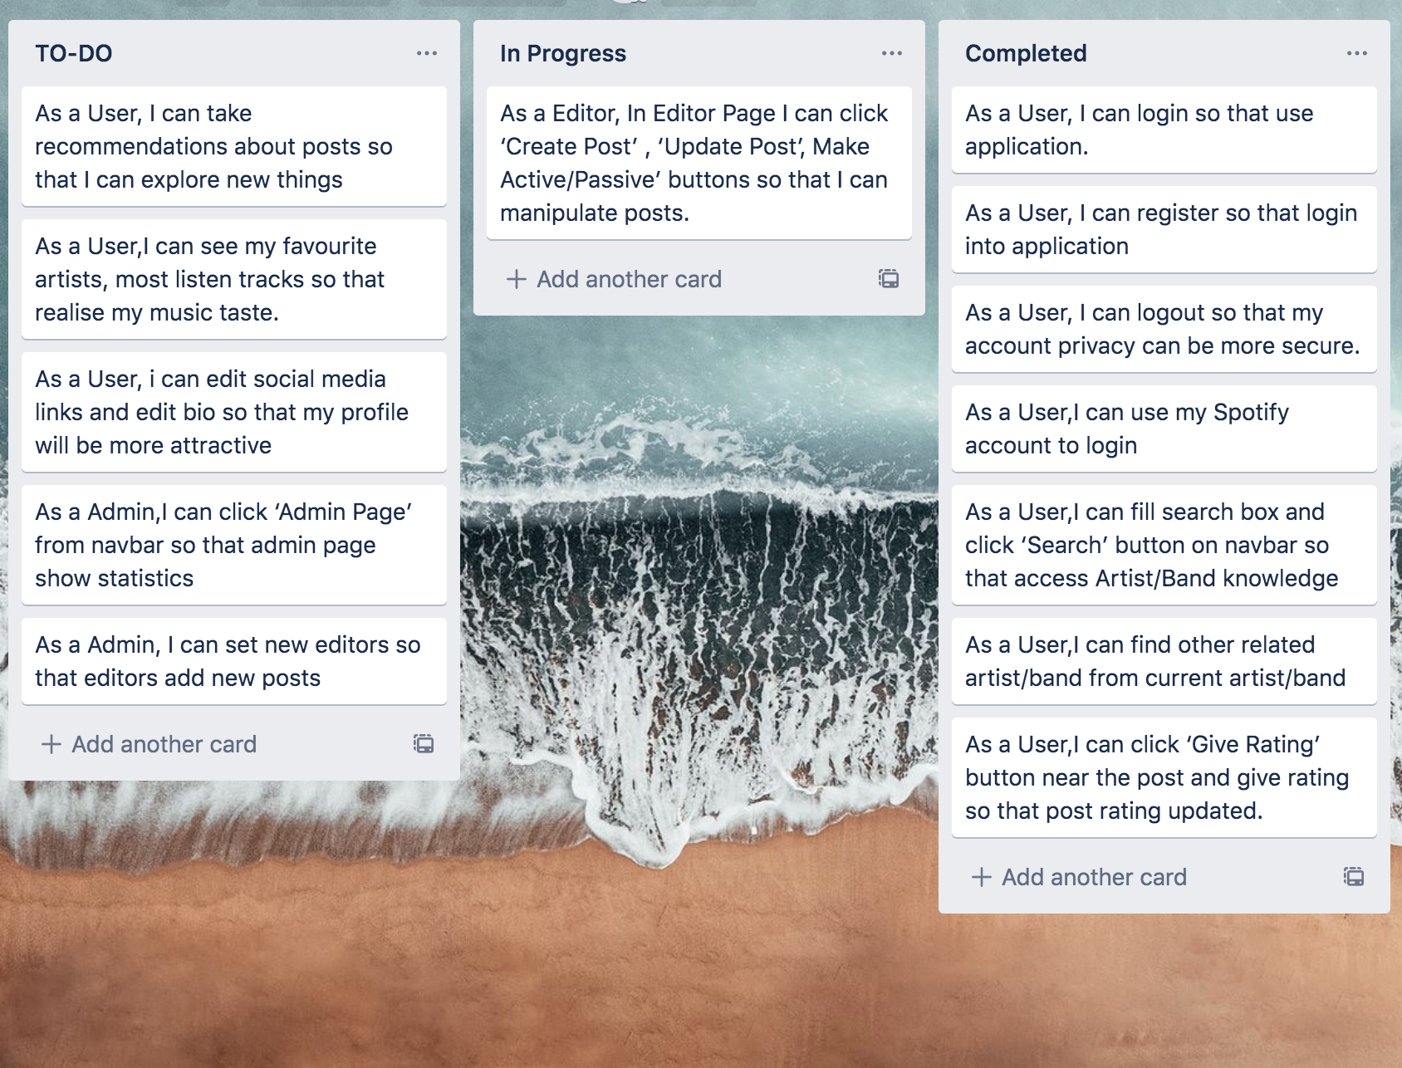

Sprint Planning for Sprint-2

We select this stories for this sprint.

What is the goal for this sprint?

In this spring we start spotify and admin process, finish of the spring our project gain main requirements.

What product backlog items are ready and contribute toward the sprint goal?

We already selected our sprint backlog items from product backlog as you can see below.

Who is available for this sprint?

Everyone is available for this sprint, there is no holiday or vacations.

What is the team’s capacity?

1.

How confident does the team feel that they’ll be able to meet the sprint goal ?

They feel comfortable.

Sprint-2 Sprint Backlog

| **ID** | Story | Estimation | Priority |
| --- | --- | --- | --- |
| **9** | As a User, I can take recommendations about posts so that I can explore new things | 3 | 9 |
| **10** | As a User,I can see my favourite artists, most listen tracks so that realise my music taste. | 3 | 10 |
| **11** | As a User, i can edit social media links and edit bio so that my profile will be more attractive | 3 | 11 |
| **12** | As a Admin,I can click ‘Admin Page’ from navbar so that admin page show statistics | 2 | 12 |
| **13** | As a Admin, I can set new editors so that editors add new posts | 2 | 13 |
| **Total** |  | **13** |  |

Just a clarify for a Sprint 2,We create our project class diagrams and also we create some code for Sprint-2 In Sprint Backlog, we complete some spotify process and also post process which are our recommends. Also now we can access lyrics of currently listening song and recommended playlist added user spotify app. Also we implement logging. Diagrams includes Sprint-2 completed backlogs.Uncompleted backlog diagrams and codes will come mvp.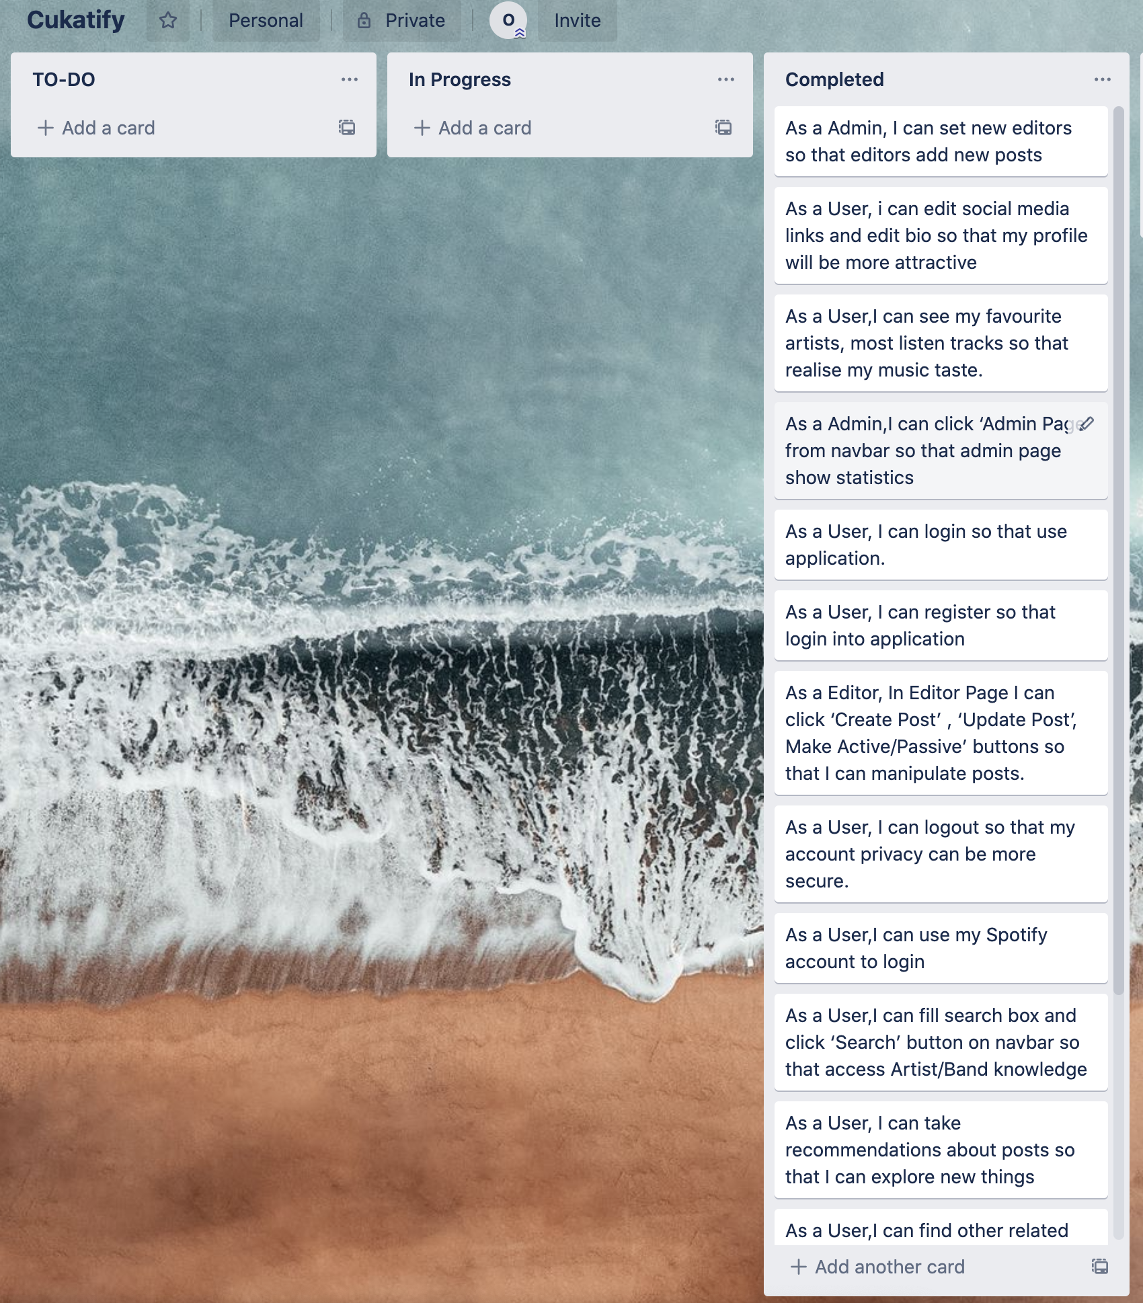

# Diagrams - Screenshots

